Vernier Caliper
# Source: AI Source: Provided by: [Data Path: Persons Table -> ID Column: 1, Name_En Column: Motasem Essam] -> From: [ChatGPT] on [7/17/2026]
A Vernier Caliper is a precision measuring instrument used to measure external dimensions, internal dimensions, depths, and step distances with much greater accuracy than a ruler or measuring tape. It combines a main scale with a vernier scale, allowing measurements to be read to fractions of a millimeter or an inch.
Vernier calipers are widely used in mechanical engineering, manufacturing, machining, quality control, metrology, laboratories, and education.

Definition
# Source: AI Source: Provided by: [Data Path: Persons Table -> ID Column: 1, Name_En Column: Motasem Essam] -> From: [ChatGPT] on [7/17/2026]
A Vernier Caliper is a precision measuring instrument that uses a main scale and a sliding vernier scale to accurately measure linear dimensions, internal dimensions, external dimensions, depths, and step heights.

Purpose
# Source: AI Source: Provided by: [Data Path: Persons Table -> ID Column: 1, Name_En Column: Motasem Essam] -> From: [ChatGPT] on [7/17/2026]
A Vernier Caliper is used to:
- Measure external dimensions.
- Measure internal dimensions.
- Measure hole diameters.
- Measure object thickness.
- Measure depths.
- Measure step heights.
- Perform precision measurements.

Main Components
# Source: AI Source: Provided by: [Data Path: Persons Table -> ID Column: 1, Name_En Column: Motasem Essam] -> From: [ChatGPT] on [7/17/2026]
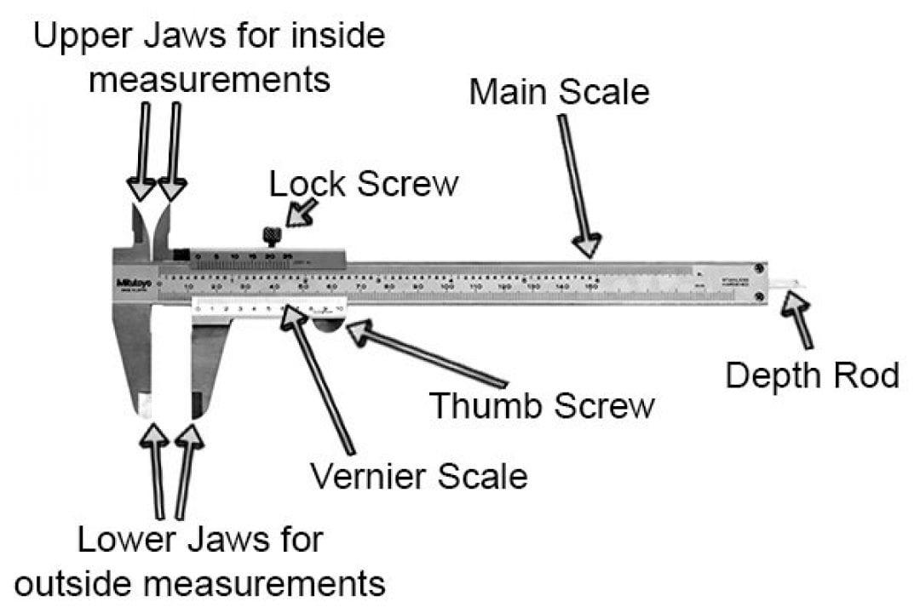
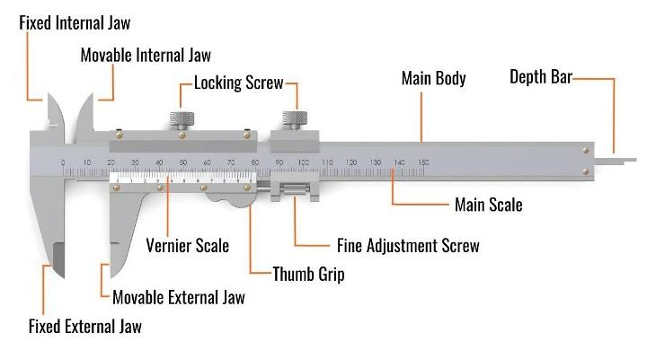
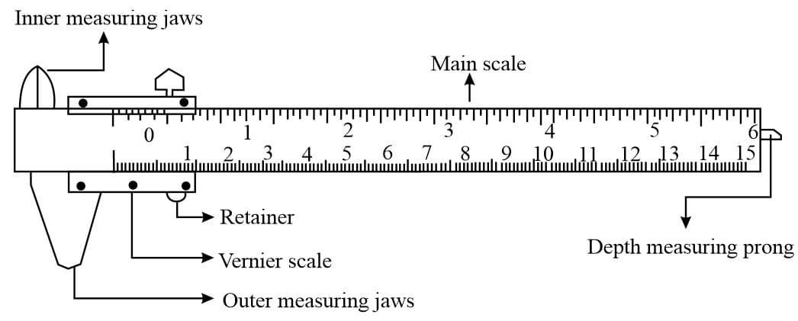
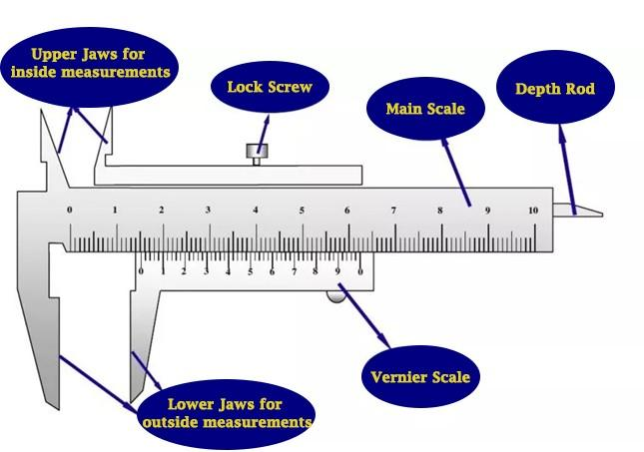
A typical Vernier Caliper consists of:
- Main Scale
- Vernier Scale
- Fixed Outside Jaw
- Movable Outside Jaw
- Inside Measuring Jaws
- Depth Rod (Depth Gauge)
- Step Measuring Faces
- Locking Screw
- Fine Adjustment (on some models)

Types of Vernier Calipers

1. Analog Vernier Caliper
# Source: AI Source: Provided by: [Data Path: Persons Table -> ID Column: 1, Name_En Column: Motasem Essam] -> From: [ChatGPT] on [7/17/2026]
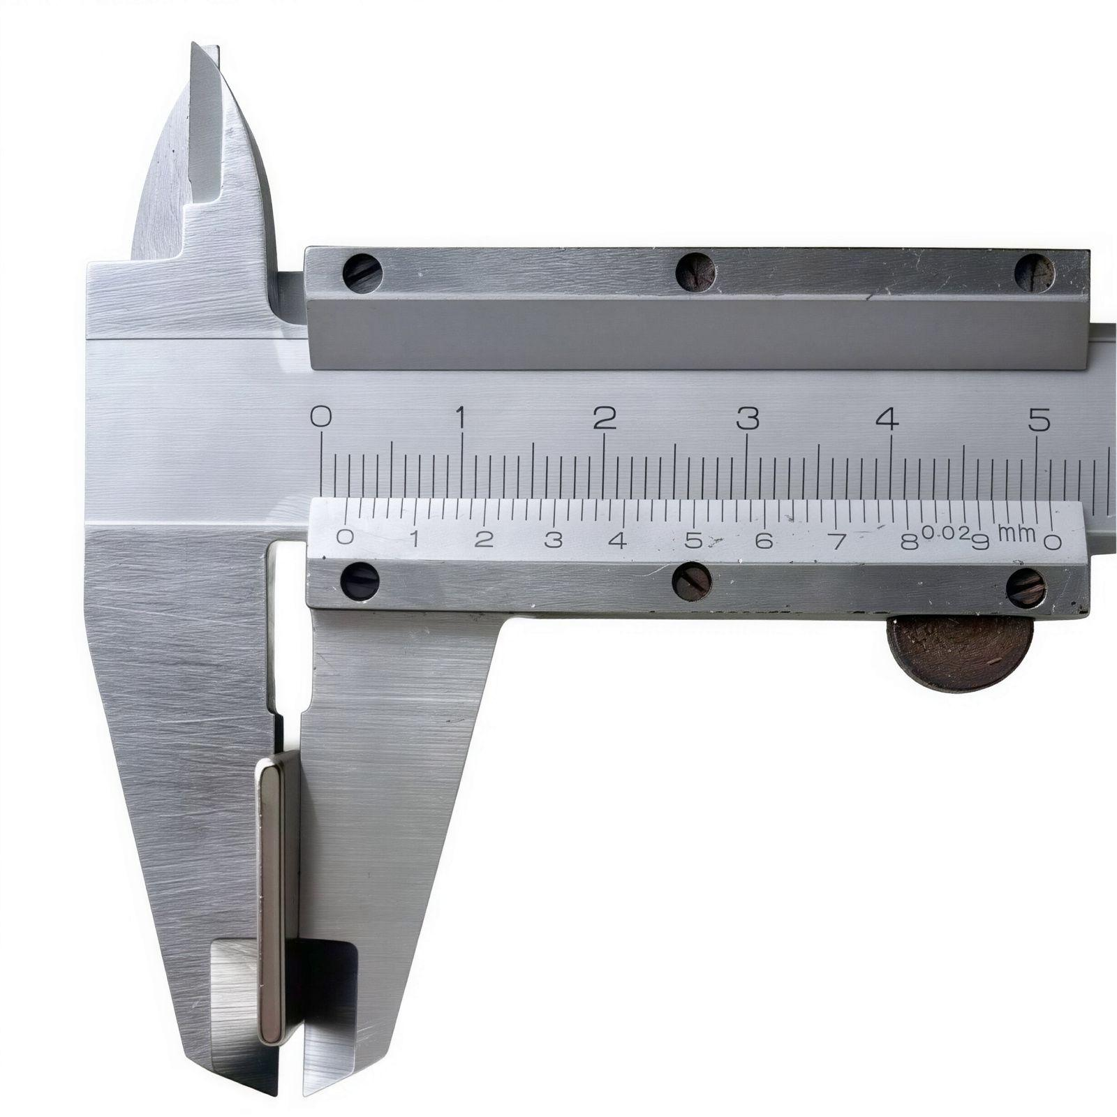
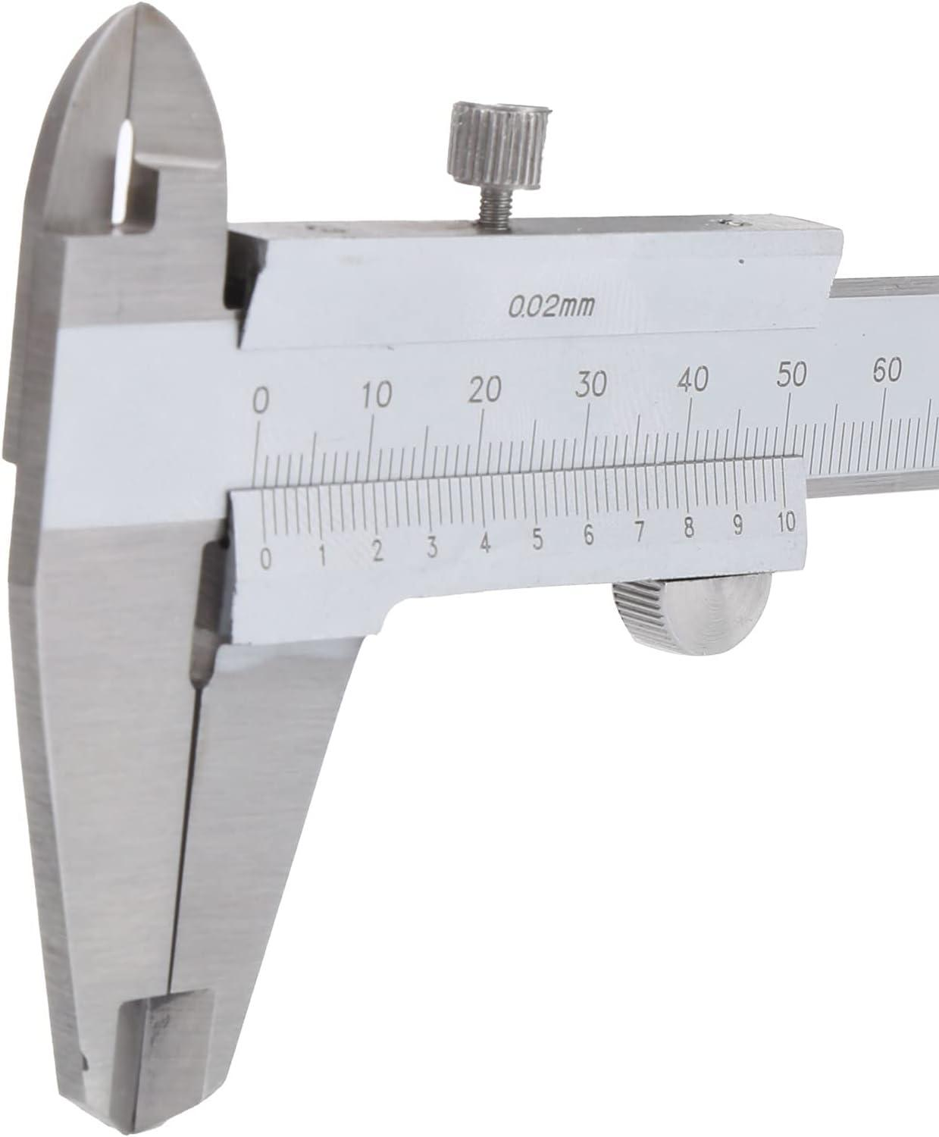
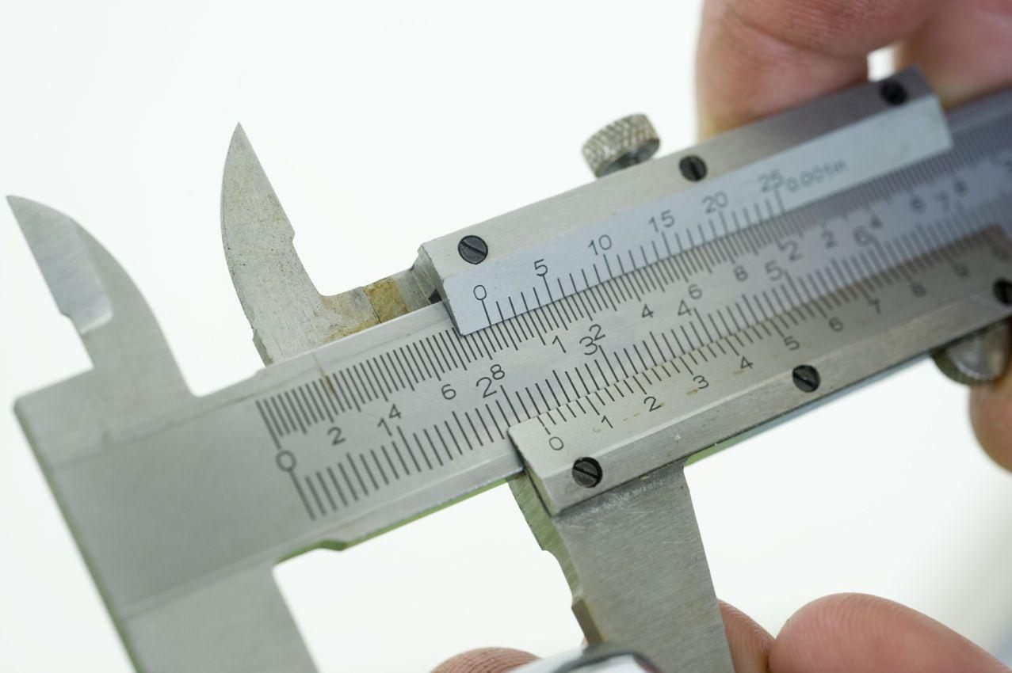
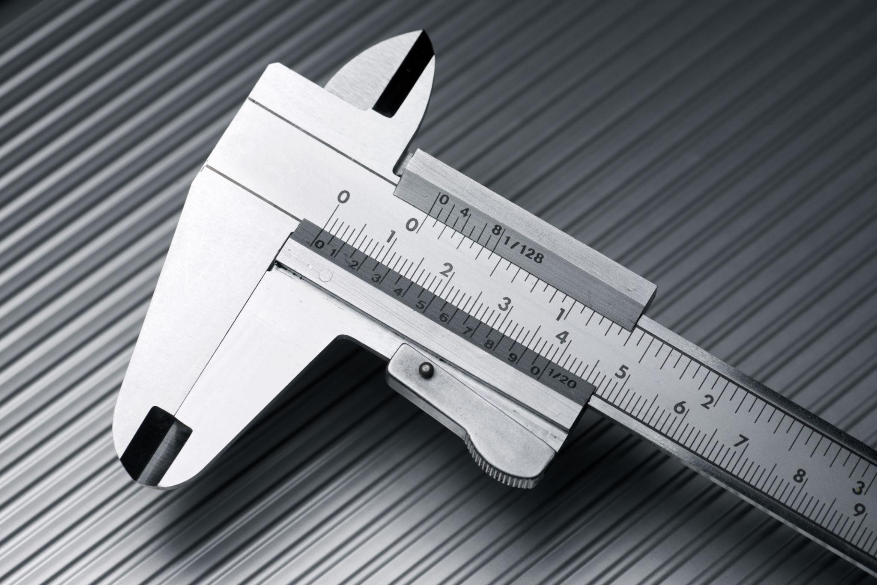
Description
An Analog Vernier Caliper uses a main scale and a sliding vernier scale to determine measurements. The user manually reads the aligned vernier division to obtain the final measurement.
Features
- Main scale and vernier scale
- No batteries required
- High mechanical durability
- Suitable for educational and industrial use
Typical Least Count
- 0.02 mm
- Sometimes 0.05 mm
Advantages
- Durable
- Reliable
- No electronic components
- Low maintenance
Applications
- Engineering workshops
- Manufacturing
- Mechanical laboratories
- Education

2. Dial Vernier Caliper
# Source: AI Source: Provided by: [Data Path: Persons Table -> ID Column: 1, Name_En Column: Motasem Essam] -> From: [ChatGPT] on [7/17/2026]
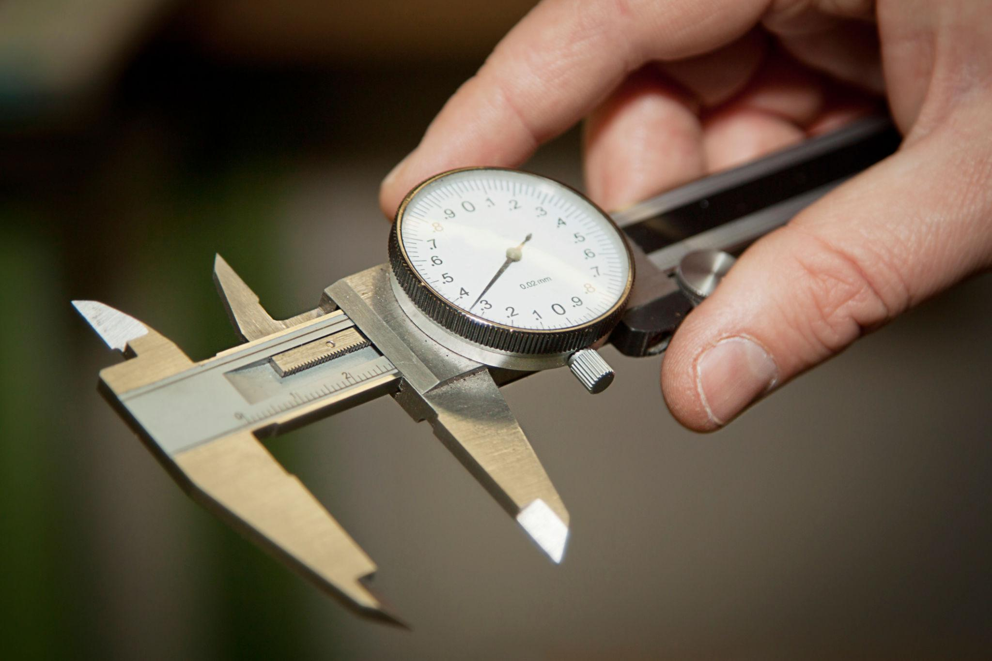
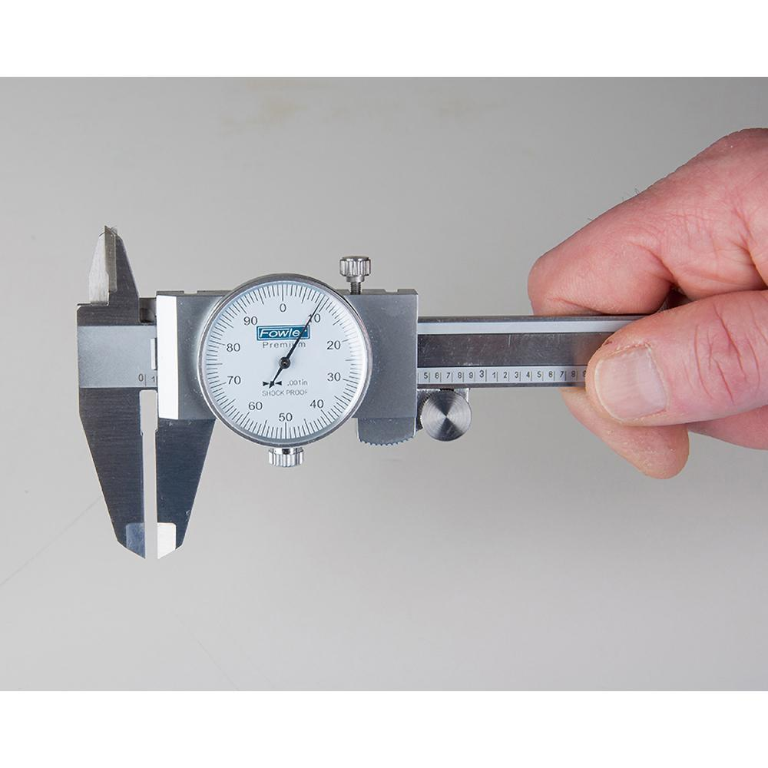
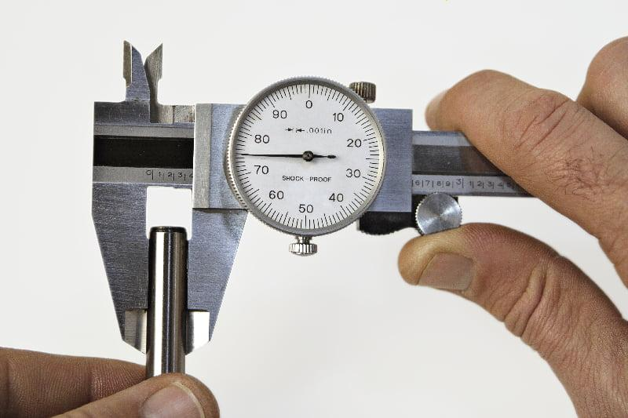
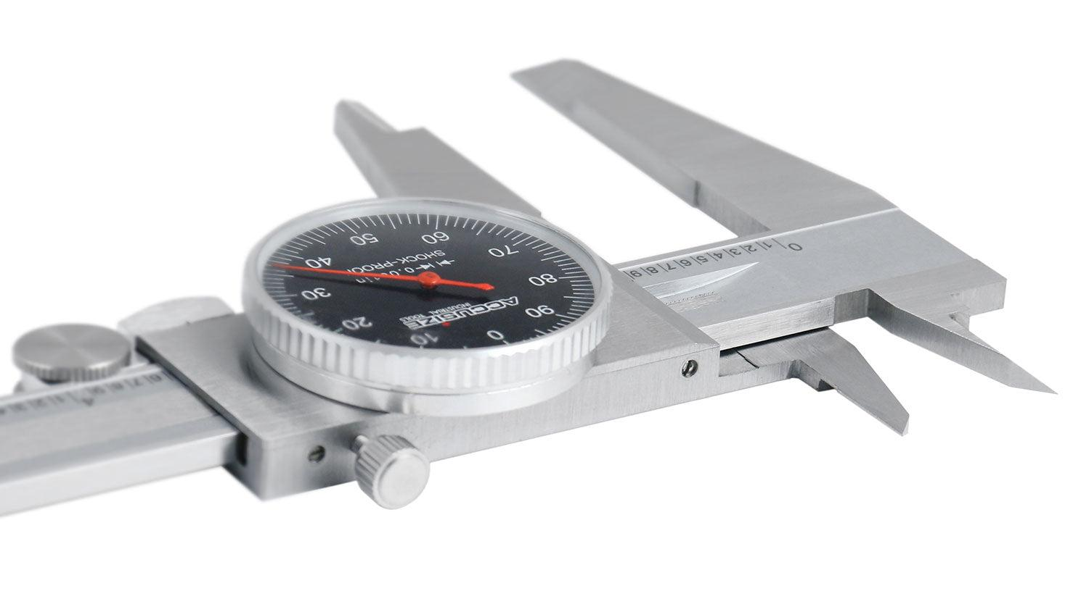
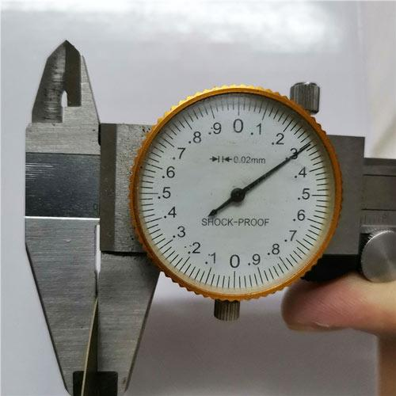
Description
A Dial Vernier Caliper, commonly called a Dial Caliper, replaces the vernier scale with a mechanical dial indicator, making measurements easier and faster to read.
Features
- Mechanical dial display
- Rack-and-pinion mechanism
- No batteries required
- Faster reading than an analog vernier caliper
Typical Least Count
- 0.01 mm
- 0.02 mm
- 0.001 in (imperial models)
Advantages
- Easier to read
- Faster measurements
- Good precision
- Durable mechanical construction
Applications
- Machine shops
- Manufacturing
- Quality inspection
- Mechanical engineering

3. Digital Vernier Caliper
# Source: AI Source: Provided by: [Data Path: Persons Table -> ID Column: 1, Name_En Column: Motasem Essam] -> From: [ChatGPT] on [7/17/2026]
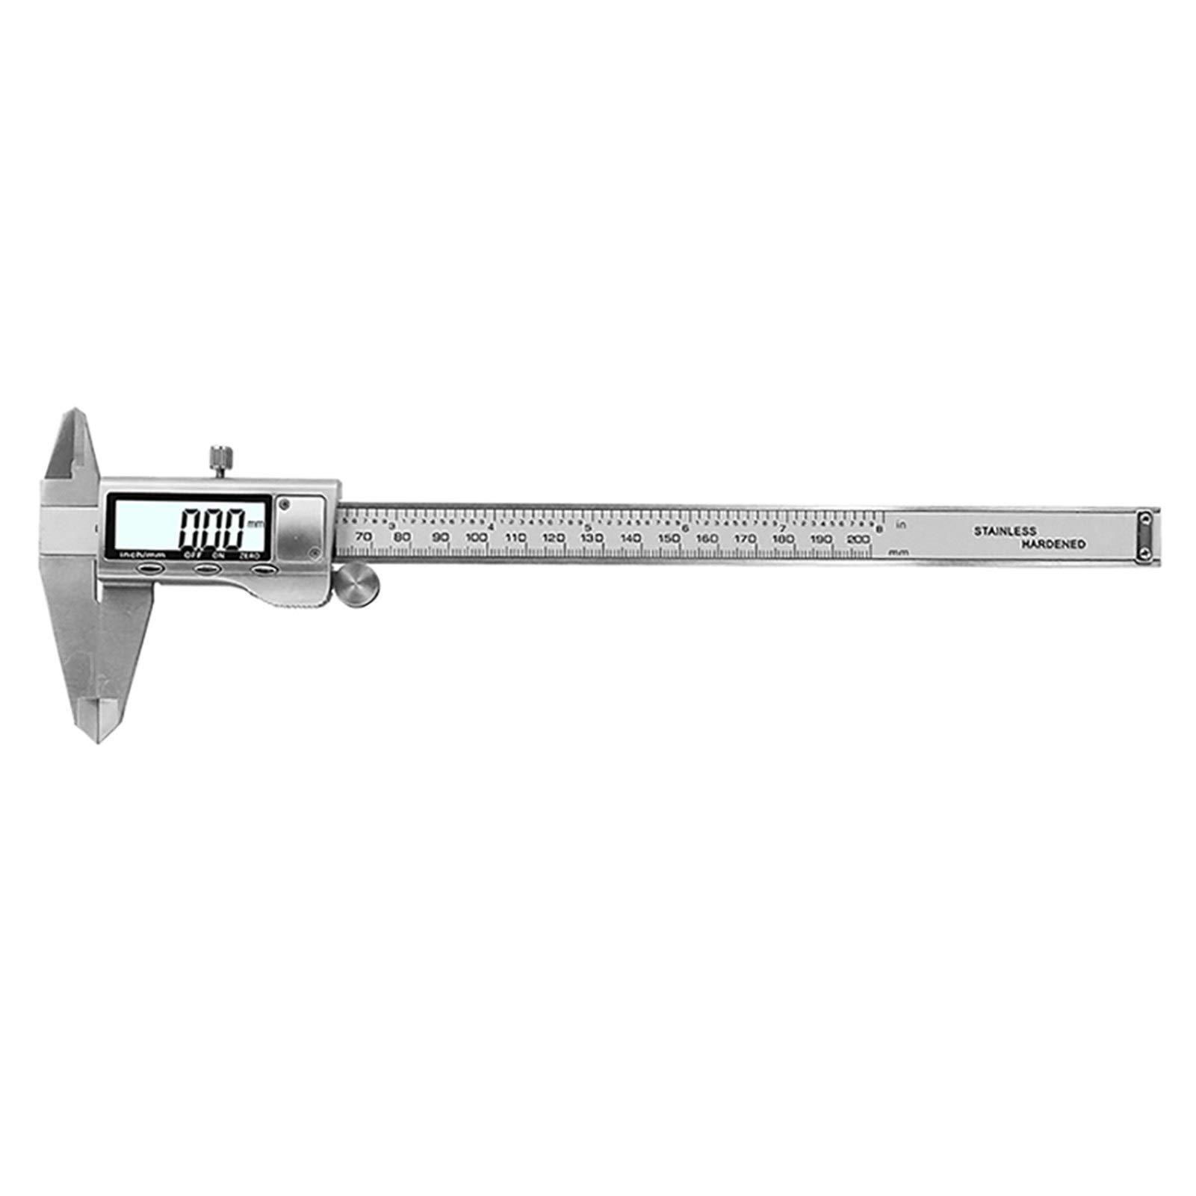
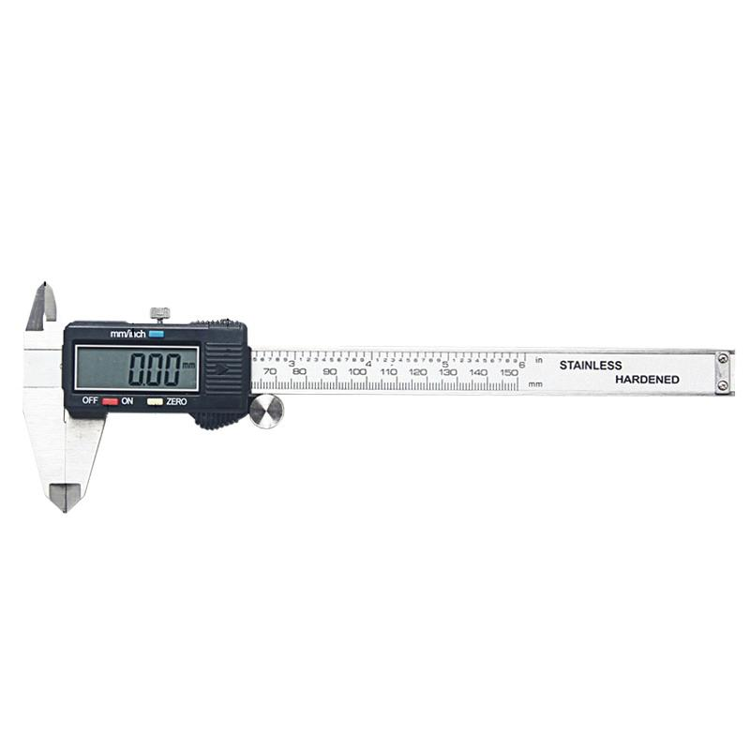
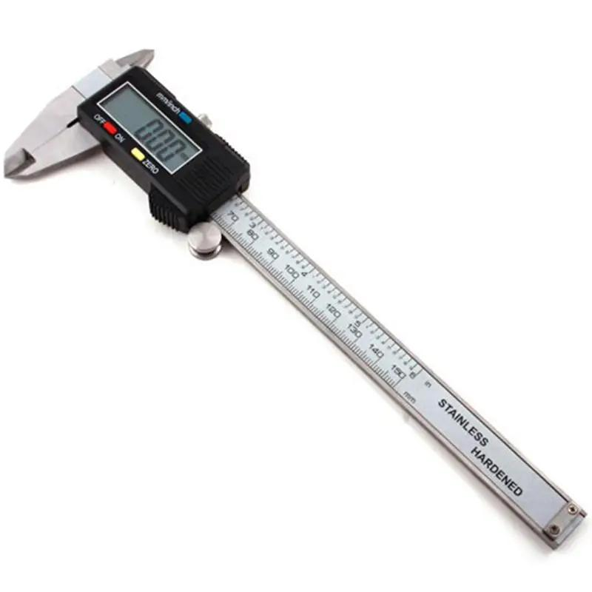
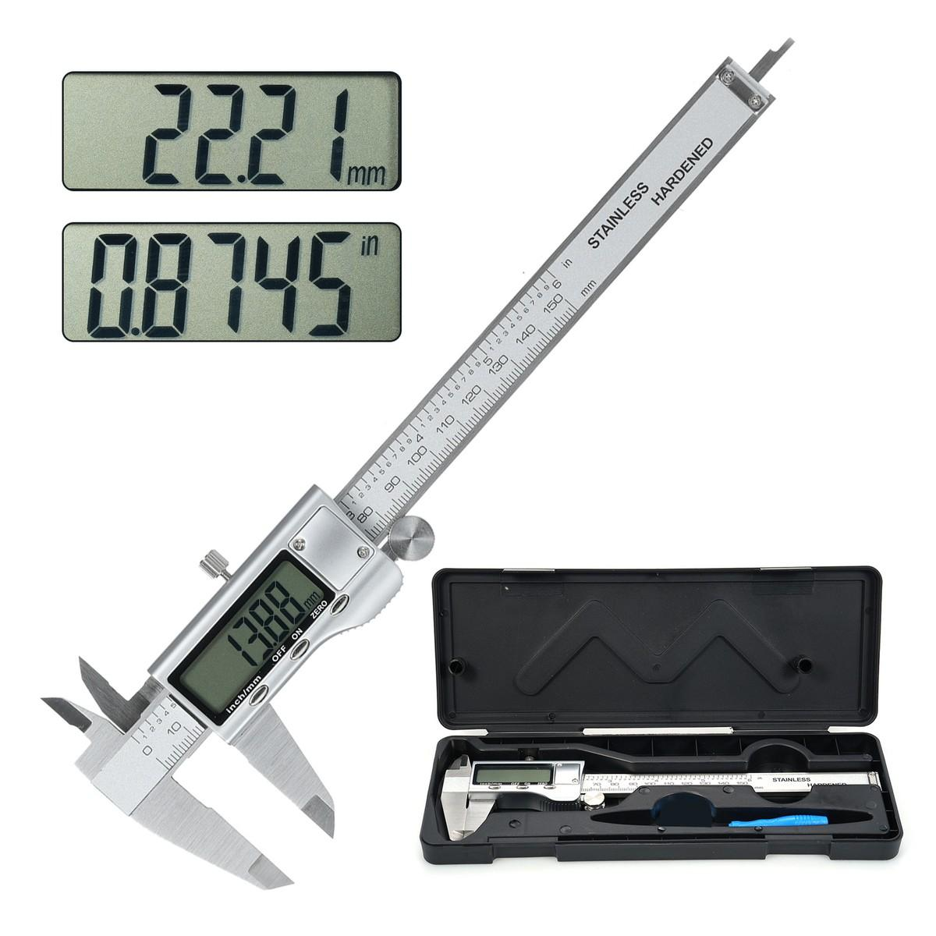
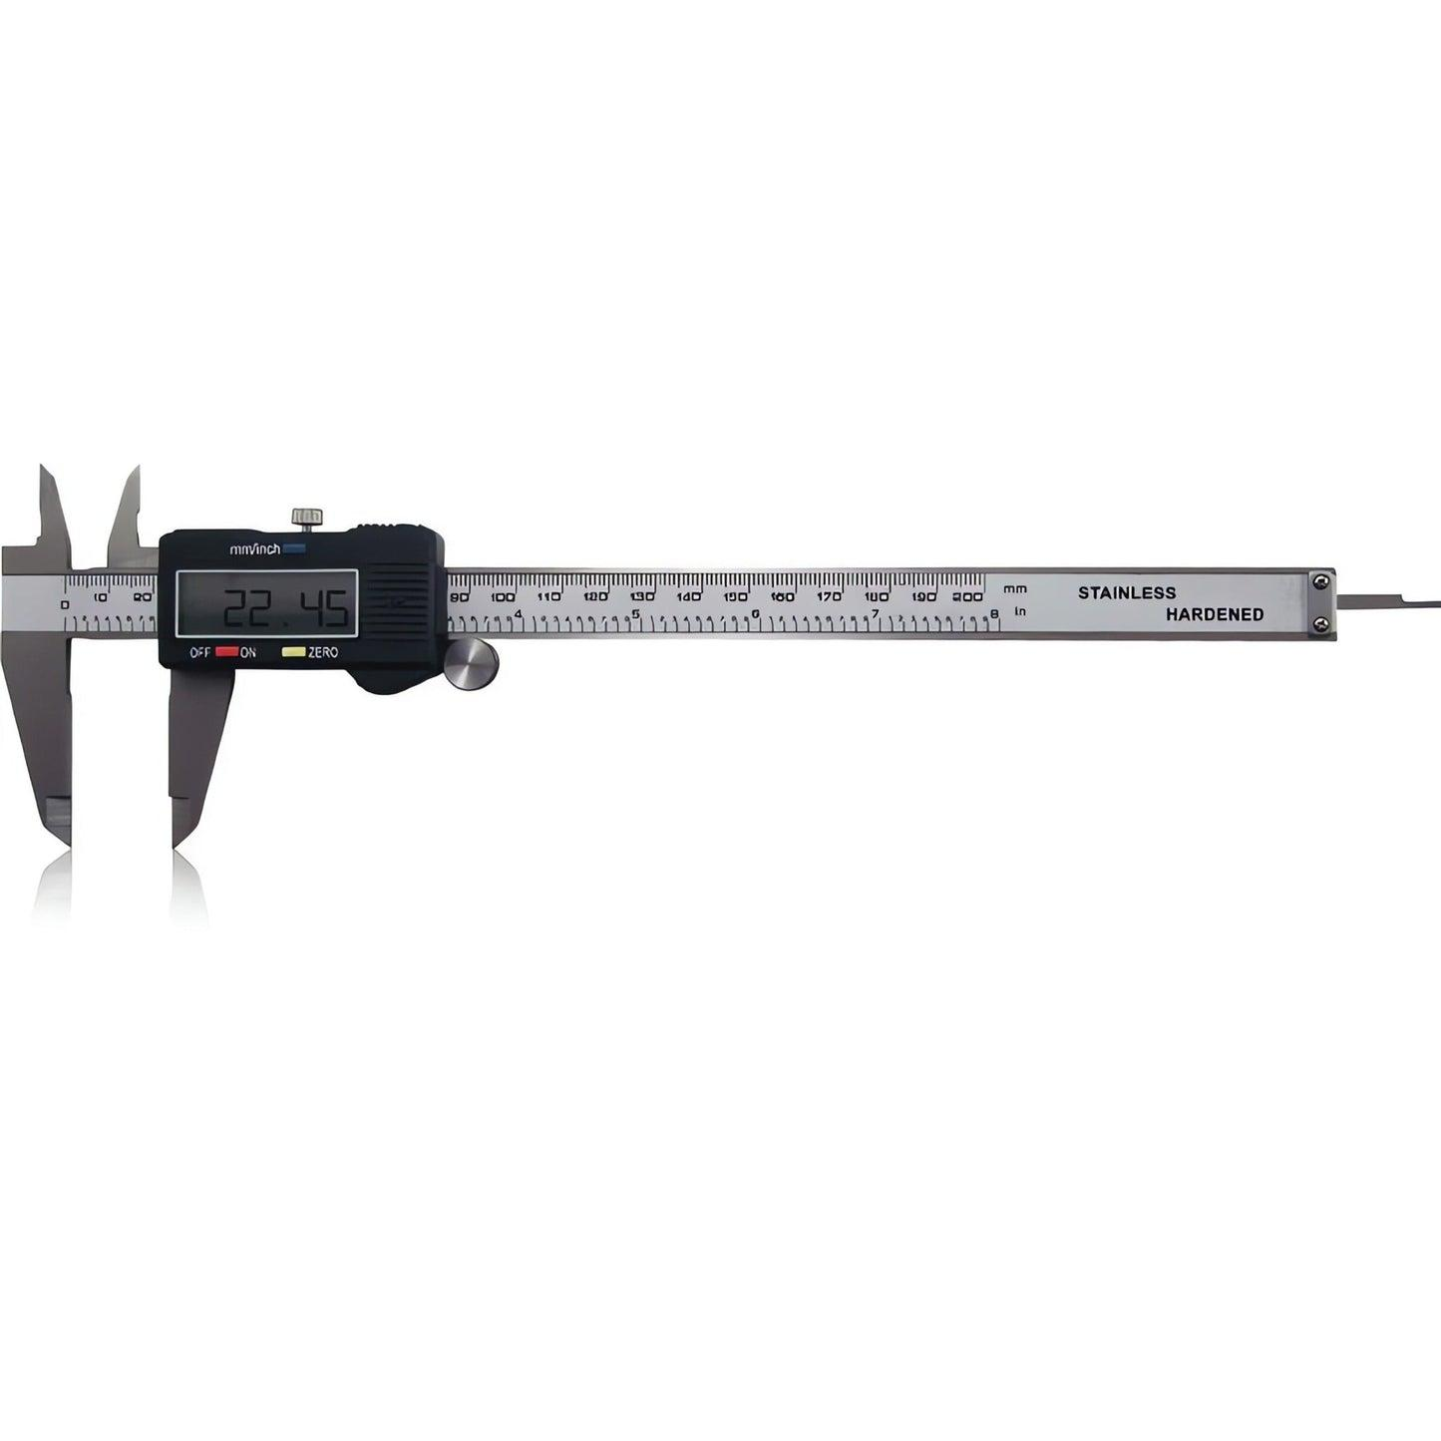
Description
A Digital Vernier Caliper uses an electronic sensor and an LCD screen to display measurements directly, eliminating the need to interpret a vernier or dial scale.
Features
- LCD digital display
- Metric/Imperial unit conversion
- Zero-setting at any position
- Battery powered
- Fast and accurate readings
Typical Least Count
- 0.01 mm
- 0.0005 in
Advantages
- Very easy to read
- High precision
- Rapid measurements
- Reduced reading errors
- Convenient unit conversion
Applications
- Precision machining
- Engineering
- Research laboratories
- Manufacturing
- Quality control

Comparison of Vernier Caliper Types
# Source: AI Source: Provided by: [Data Path: Persons Table -> ID Column: 1, Name_En Column: Motasem Essam] -> From: [ChatGPT] on [7/17/2026]
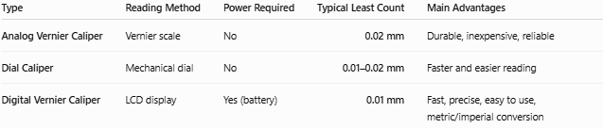
Type | Reading Method | Power Required | Typical Least Count | Main Advantages
Analog Vernier Caliper | Vernier scale | No | 0.02 mm | Durable, inexpensive, reliable
Dial Caliper | Mechanical dial | No | 0.01–0.02 mm | Faster and easier reading
Digital Vernier Caliper | LCD display | Yes (battery) | 0.01 mm | Fast, precise, easy to use, metric/imperial conversion

Measuring Capabilities
# Source: AI Source: Provided by: [Data Path: Persons Table -> ID Column: 1, Name_En Column: Motasem Essam] -> From: [ChatGPT] on [7/17/2026]
A Vernier Caliper can measure:
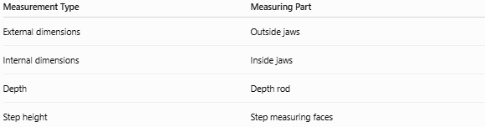
Measurement Type | Measuring Part
External dimensions | Outside jaws
Internal dimensions | Inside jaws
Depth | Depth rod
Step height | Step measuring faces

Measuring Range
# Source: AI Source: Provided by: [Data Path: Persons Table -> ID Column: 1, Name_En Column: Motasem Essam] -> From: [ChatGPT] on [7/17/2026]
Common measuring ranges include:
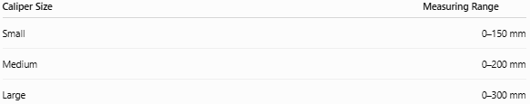
Caliper Size | Measuring Range
Small | 0–150 mm
Medium | 0–200 mm
Large | 0–300 mm

Least Count (Resolution)
# Source: AI Source: Provided by: [Data Path: Persons Table -> ID Column: 1, Name_En Column: Motasem Essam] -> From: [ChatGPT] on [7/17/2026]
The least count is the smallest measurable value.
Typical values:
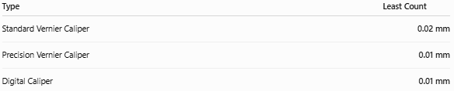
Type | Least Count
Standard Vernier Caliper | 0.02 mm
Precision Vernier Caliper | 0.01 mm
Digital Caliper | 0.01 mm

How a Vernier Scale Works
# Source: AI Source: Provided by: [Data Path: Persons Table -> ID Column: 1, Name_En Column: Motasem Essam] -> From: [ChatGPT] on [7/17/2026]
The Vernier Scale divides the smallest division of the main scale into smaller increments.
The measurement is calculated as:
Measurement = Main Scale Reading + Vernier Scale Reading
where:
- Main Scale Reading (MSR): The value on the main scale immediately before the zero of the vernier scale.
- Vernier Scale Reading (VSR): The value obtained from the vernier division that exactly aligns with a main-scale division.
Mathematically:
$$\boxed{\text{Measurement}=\text{MSR}+(\text{Coinciding Vernier Division}×\text{Least Count})}$$

Example
# Source: AI Source: Provided by: [Data Path: Persons Table -> ID Column: 1, Name_En Column: Motasem Essam] -> From: [ChatGPT] on [7/17/2026]
Suppose:
- Main Scale Reading = 25 mm
- Coinciding Vernier Division = 13
- Least Count = 0.02 mm
Then:
Vernier Reading = $13×0.02=0.26\text{ mm}$
Final Measurement:
$$25+0.26=25.26\text{ mm}$$
Measured value = 25.26 mm

Accuracy
# Source: AI Source: Provided by: [Data Path: Persons Table -> ID Column: 1, Name_En Column: Motasem Essam] -> From: [ChatGPT] on [7/17/2026]
Typical accuracy:
- ±0.02 mm (standard analog)
- ±0.01 mm (precision or digital)
Accuracy depends on:
- Instrument quality
- Calibration
- User technique
- Wear of measuring jaws

Sources of Error

Instrument Errors
# Source: AI Source: Provided by: [Data Path: Persons Table -> ID Column: 1, Name_En Column: Motasem Essam] -> From: [ChatGPT] on [7/17/2026]
- Worn jaws
- Calibration errors
- Damaged vernier scale
- Dirt between measuring surfaces

Observation Errors
# Source: AI Source: Provided by: [Data Path: Persons Table -> ID Column: 1, Name_En Column: Motasem Essam] -> From: [ChatGPT] on [7/17/2026]
- Incorrect reading of the vernier scale
- Parallax error (analog types)
- Misidentifying the coinciding vernier line

Positioning Errors
# Source: AI Source: Provided by: [Data Path: Persons Table -> ID Column: 1, Name_En Column: Motasem Essam] -> From: [ChatGPT] on [7/17/2026]
- Object not seated correctly between jaws
- Excessive measuring force
- Misalignment of the workpiece

Environmental Errors
# Source: AI Source: Provided by: [Data Path: Persons Table -> ID Column: 1, Name_En Column: Motasem Essam] -> From: [ChatGPT] on [7/17/2026]
- Temperature expansion
- Dust
- Moisture
- Vibration

Applications
# Source: AI Source: Provided by: [Data Path: Persons Table -> ID Column: 1, Name_En Column: Motasem Essam] -> From: [ChatGPT] on [7/17/2026]
Vernier Calipers are used in:
- Mechanical engineering
- Manufacturing
- Machining
- Automotive industry
- Aerospace
- Tool making
- Laboratories
- Quality control
- Metrology
- Education

Advantages
# Source: AI Source: Provided by: [Data Path: Persons Table -> ID Column: 1, Name_En Column: Motasem Essam] -> From: [ChatGPT] on [7/17/2026]
A Vernier Caliper:
- Provides high precision.
- Measures multiple types of dimensions.
- Is portable.
- Does not require electricity (analog type).
- Is more accurate than a ruler or measuring tape.

Limitations
# Source: AI Source: Provided by: [Data Path: Persons Table -> ID Column: 1, Name_En Column: Motasem Essam] -> From: [ChatGPT] on [7/17/2026]
A Vernier Caliper:
- Requires proper reading technique (analog type).
- Is less accurate than a micrometer for very fine measurements.
- Can be damaged by improper handling.
- Requires periodic calibration.

Comparison with Other Length Measuring Instruments
# Source: AI Source: Provided by: [Data Path: Persons Table -> ID Column: 1, Name_En Column: Motasem Essam] -> From: [ChatGPT] on [7/17/2026]
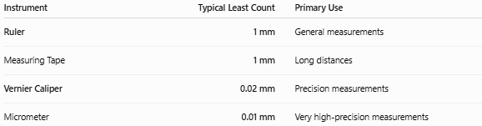
Instrument | Typical Least Count | Primary Use
Ruler | 1 mm | General measurements
Measuring Tape | 1 mm | Long distances
Vernier Caliper | 0.02 mm | Precision measurements
Micrometer | 0.01 mm | Very high-precision measurements

Care and Maintenance
# Source: AI Source: Provided by: [Data Path: Persons Table -> ID Column: 1, Name_En Column: Motasem Essam] -> From: [ChatGPT] on [7/17/2026]
To maintain accuracy:
- Keep the measuring surfaces clean.
- Avoid dropping the instrument.
- Store it in a protective case.
- Apply light oil to steel calipers when necessary.
- Check for zero error before use.
- Calibrate periodically.

Common Mistakes
# Source: AI Source: Provided by: [Data Path: Persons Table -> ID Column: 1, Name_En Column: Motasem Essam] -> From: [ChatGPT] on [7/17/2026]
- Ignoring zero error.
- Applying excessive pressure.
- Reading the wrong vernier division.
- Measuring dirty or rough surfaces.
- Using worn measuring jaws.

Key Points
# Source: AI Source: Provided by: [Data Path: Persons Table -> ID Column: 1, Name_En Column: Motasem Essam] -> From: [ChatGPT] on [7/17/2026]
- A Vernier Caliper is a precision measuring instrument.
- It measures:
  - External dimensions
  - Internal dimensions
  - Depths
  - Step heights
- Typical least count:
  - 0.02 mm
  - 0.01 mm (digital/precision)
- It is significantly more accurate than a ruler or measuring tape.
- It is widely used in engineering, manufacturing, and quality control.

Conclusion
# Source: AI Source: Provided by: [Data Path: Persons Table -> ID Column: 1, Name_En Column: Motasem Essam] -> From: [ChatGPT] on [7/17/2026]
The Vernier Caliper is one of the most versatile and widely used precision measuring instruments. By combining a main scale with a vernier scale, it enables accurate measurement of external, internal, depth, and step dimensions with resolutions commonly as fine as 0.02 mm or 0.01 mm. Its combination of precision, versatility, and portability makes it indispensable in engineering, machining, manufacturing, metrology, and scientific laboratories, where accurate dimensional measurement is essential.

